

The



is proud to announce the FY25 Milk/Dairy Safety

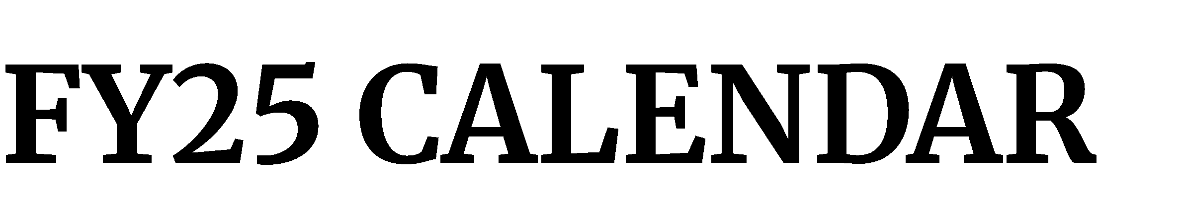

Training Calendar. Registrations for course sessions will be accepted once the course announcement is issued. Course announcements are issued on a rolling basis, usually 12 weeks prior to the course. Course announcements will include course registration instructions and required prerequisites or pre-work. **Questions about courses?** Email us at oraotedmilk@fda.hhs.gov

**This calendar is subject to change.** Please visit the [LearnED Learning Management System](https://fdaoted.csod.com/login/render.aspx?id=fdaotedclp) for the latest updates at https://fdaoted.csod.com/login/render.aspx?id=fdaotedclp

|  |  |  |  |  |
| --- | --- | --- | --- | --- |
| **Course ID** | **Description** | **Location/Virtual** | **Start Date** | **End Date** |
| [**FD371: Milk Pasteurization Controls and Tests**](https://fdaoted.csod.com/ui/lms-learning-details/app/event/1948cccf-1b09-4300-8b11-bc03a584c7c4) | This course seeks to develop the skills necessary to evaluate basic and complex pasteurization systems. Participants use pasteurizer controllers and instrumentation and perform practical sessions. When possible, a processing plant field trip is integrated into the training to demonstrate product flows and equipment testing. | | | | |
| FD371 Milk Pasteurization Controls and Tests Baton Rouge, LA 05/05/25 - 1PM 05/09/25 - Noon | | | | |
| FD371 Milk Pasteurization Controls and Tests Tampa, FL 06/02/25 - 1PM 06/06/25 - Noon | | | | |
| [**FD372 Milk Plant Sanitation and Inspection**](https://fdaoted.csod.com/ui/lms-learning-details/app/event/03d417d1-e996-4ca9-a054-ac72ef695bb8) | This course is designed to provide participants with the knowledge and skills  necessary to evaluate and inspect the sanitary status of milk plants, using the current applicable sections of the current edition of the Pasteurization Milk Ordinance, 3A Sanitary Standards, and other applicable guidelines. Classroom instruction and milk plant field trips help provide the participant with the following topic information: inspection techniques, equipment, and process control, identifying chemical, biological and physical hazards, current quality assurance concepts and milk processing sanitary procedures. | | | | |
| FD372 Milk Plant Sanitation and Inspection San Antonio, TX 03/03/25 - 1PM 03/07/25 - Noon | | | | |
| FD372 Milk Plant Sanitation and Inspection Denver, CO 05/19/25 - 1PM 05/23/25 - Noon | | | | |
| FD372 Milk Plant Sanitation and Inspection Albany, NY 06/09/25 - 1PM 06/13/25 - Noon | | | | |
| [**FD375: Dairy Farm Sanitation and Inspections**](https://fdaoted.csod.com/ui/lms-learning-details/app/event/2f647140-c4d7-4c1c-bf6f-e3a44fca5317) | This course is designed to develop the skills necessary to evaluate basic and complex dairy farm systems. Participants evaluate dairy farm equipment, instrumentation and systems will either perform virtual or hands-on practical sessions and, when possible, participate in dairy farm field trips to demonstrate product flows and inspection process. This course also incorporates information on inspection techniques, equipment, and process control, identifying chemical, biological and physical hazards, current quality assurance concepts and dairy farm sanitary procedures. | | | | |
| FD375 Dairy Farm Sanitation and Inspections Fresno, CA 04/28/25 - 1PM 05/02/25 - Noon | | | | |
| FD375 Dairy Farm Sanitation and Inspections Minneapolis, MN 09/08/25 - 1PM 09/12/25 - Noon | | | | |
| [**FD577 Special Problems in Milk Protection**](https://fdaoted.csod.com/ui/lms-learning-details/app/event/647352b8-7821-414a-97ea-3123238fbd7e) | This course meets the National Conference on Interstate Milk Shipments criteria for  State Milk Rating Officers certification. Course content is advanced and is designed to meet specific needs of the State Milk Rating Officers. Previous workshops have included the following topics: conducting ratings of single-farm and multiple farm BTUs, milk plants and single-service container and/or closure facilities, Appendix T. Limit Scope audits, Hauler/Sampler evaluations and honing skills on determining substantial compliance during ratings and check ratings . | | | | |
| FD577 Special Problems in Milk Protection Hendersonville, TN 06/03/25 - 8AM 06/05/25 - 5PM | | | | |
| FD577 Special Problems in Milk Protection Grand Rapids, MI 08/19/25 - 8AM 08/21/25 - 5PM | | | | |
| [**FD578 Advanced Milk Processing**](https://fdaoted.csod.com/ui/lms-learning-details/app/event/e3fc8068-cad1-4d16-8709-168f74424cb9) | This course covers key topics to include: HHST Pasteurization Principles, VTIS Design and Operation, HHST testing requirements, Aseptic Processing and Packaging, Computer Controls, Trace-back/Ladder Logic, UV light disinfection/Pasteurized Equivalent Water, membrane technologies, drying technology, and evaporation technology. | | | | |
| FD578 Advanced Milk Processing Buffalo, NY 08/11/25 - 8AM 08/14/25 - 5PM | | | | |
| FD578 Advanced Milk Processing Salt Lake City, UT 09/15/25 - 8AM 09/18/25 - 5PM | | | | |