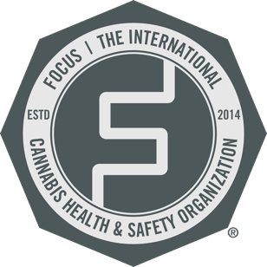
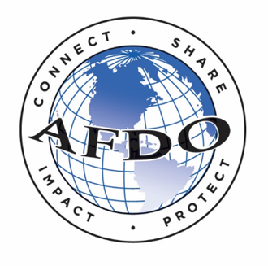

127th AFDO AEC Cannabis Speaker Contact Information

Session Title | Speaker | Company | Email
A New Way Forward | Patrick Cournoyer, Ph.D | FDA | patrick.cournoyer@fda.hhs.gov
Balancing Intent & Impact | Steve Bevan | O’Can Group | steve@ocangroup.com
 | Brett Goldman | O’Can Group | brett@ocangroup.com
Unveiling Hidden Risks | Niki Holm | IMA Insurance | niki.holm@imacorp.com
 | Thuy Vu | Thuy Vu Consulting | thuy@thuyvu.com
From the Front Lines | Soorena Khojasteh, MD | Main Line Health | khojastehs@mlhs.org
Remediation & Decontamination | Tess Eidem, Ph.D | Rouge Micro | tess@rougemicrollc.com
Remediation & Decontamination | Kyle Baker | Clean Theory | kyle@ecobuds.net
Inspector Bootcamp | Cori Muse | Muse Food Safety | cori@foodsafetymuse.com
Moderator | Lezli Engelking | FOCUS | lezli@focusstandards.org

