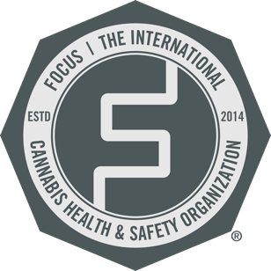

Cannabis Quality Management System Training
Complementary Access for Regulators

FOCUS and AFDO are pleased to offer state and federal regulators complimentary access to the first and only ANAB Accredited Quality Management System Training for Cannabis. Courses are based upon FOCUS Standards requirements and guidance, in partnership with Cogneti Training.

- You can read the official certificate program document as an introduction.
- The program is available as a self-guided app on the web, or iOS app store, or Android play store.
- In the program app you’ll first be asked to register. Then you’ll be challenged to pay a license fee. Please reach out to Chris Gray at cgray@cogneti.com. He will provide a custom code for your state that will cover the license fee.

We hope you find this training valuable and would greatly appreciate any feedback you have.

