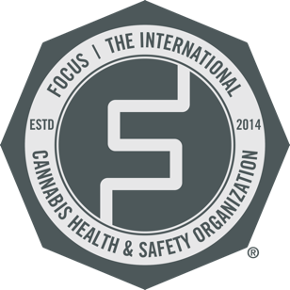
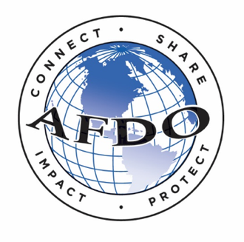

AFDO Cannabis Committee

Please use the link below to sign up for the 2023/2024 AFDO Cannabis Committee. This year we will be working on updating FOCUS standards, with a special emphasis on nomenclature.

Sign Up Link: https://www.afdo.org/committee-preference/

Should you run into any trouble, please click here to submit a contact form with AFDO, or click here to email Tressa McGill directly.

We look forward to working with you to help build a safe, legal, and sustainable cannabis industry.

