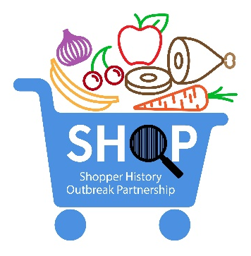
Shopper History Success Story Submission Form

Submitter Information
First Name:
Last Name:
Agency/Organization:
Email Address:
Phone Number:

Summary (for external use and posting on the AFDO webpage: Leveraging Food Purchase History to Solve Foodborne Outbreaks)
Please keep the summary high level and de-identify any retailers/establishments. Highlight relevant outcomes, including:
- Use of this data that led to solving an outbreak or other good investigation/public health outcome.
- Strengthened industry-government collaboration.
- Innovative mechanisms developed or used by industry or government.
- Development of useful resources.

Template:

(Insert Pathogen) Outbreak Associated with (Insert Product) – (Insert Shopper History Mechanism – Debit Card, Shopper Card, Online App, etc)
In a (Year) outbreak of (Number of cases) (Pathogen) illnesses from (Number of states) states linked to (product), (describe shopper history mechanism and how it was used to investigate the outbreak, highlighting outcome).

Additional Information (optional – will not be shared publicly):
Pathogen:
Product:
Retailer (optional):
Shopper History Method:
Public Health Impact:
Number of states:
Number of cases:
Public information (links to outbreak-related web postings):

